How to run the Hospital Management system Django Python
1. Download the zip file
2. Extract the file, copy hms folder, and paste it on the desktop

3. Open MySQL Create a database hmspythondb then import the SQL File available in the SQL File Folder (For MySQL we used XAMPP server)

4. Open PyCharm and click on the terminal
5. Navigate the project folder using the cd command
cd project_path

For ex: cd C:\Users\ANUJ\OneDrive\Desktop\hms\

6. Now Navigate to the hospital folder
cd hospital

7. Run the Project using the following command
python manage.py runserver
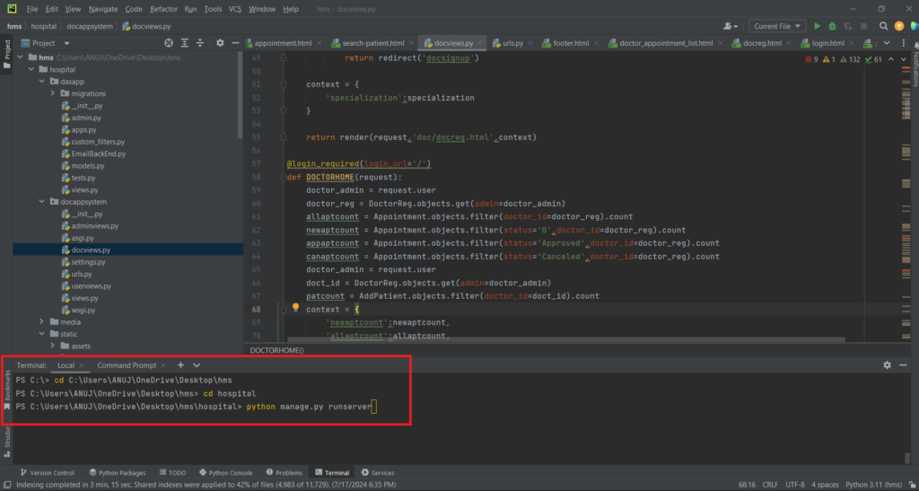

Now click the URL http://127.0.0.1:8000 and the Project will Run

Login Details
*************admin************
Username: admin@gmail.com
Password: Test@123

*************Doctor************
Username: john12@gmail.com
Password: Test@123 OR Register new doctor

*************User/Patient************
Username: amit123@gmail.com
Password: Test@123 OR Register new doctor

